DESIGN AND IMPLEMENTATION
HOTEL SYSTEM NETWORK DESIGN
Project Report

Student Name: Dur e Adan , Hadia Sohail , Noor Ul Ain
Course Name: Computer Networks / Network Design
Institution: Pakistan Institute of Engineering and Applied Sciences
Submission Date: May 10,2026

1. Abstract

This project presents the design and simulation of a secure and scalable multi-floor hotel network using Cisco Packet Tracer. The objective was to create a fully functional enterprise network that supports efficient communication between different departments across three floors of a hotel while maintaining strong network security.

The network was designed with three floors, each containing a dedicated switch and router. Eight departments were distributed across the floors including Reception, Store, Logistics, Finance, Human Resources, Sales, IT Department, and Administration. Each department was assigned a separate VLAN to isolate traffic and improve network performance.

Several key technologies were implemented throughout the project. VLANs were configured for traffic segmentation, while router-on-a-stick method was used for inter-VLAN routing. OSPF routing protocol was configured across all three routers to enable dynamic routing and seamless communication between floors. DHCP was configured on each router to automatically assign IP addresses to all devices. SSH was enabled on all routers to allow secure remote management from the Test-PC located in the IT Department. Port security was implemented on the IT department switch to restrict unauthorized access. Additionally, wireless access points were installed on the first and second floors to provide Wi-Fi connectivity for mobile devices.

The simulation was successfully tested and verified in Cisco Packet Tracer. All devices received correct IP addresses, inter-VLAN and inter-floor communication was confirmed, SSH remote access was established, and wireless connectivity was achieved, demonstrating a fully operational hotel network.

2. Introduction

2.1 Background
The hospitality industry relies heavily on efficient and secure network infrastructure to support its day-to-day operations. In a modern hotel environment, multiple departments such as Reception, Finance, Human Resources, IT, and Administration must communicate seamlessly while maintaining data security and privacy. A poorly designed network can lead to security breaches, slow performance, and communication failures that directly impact guest experience and business operations.
Proper network design in a hotel environment requires careful planning of traffic segmentation, secure remote access, and reliable connectivity across multiple floors and departments. This project was motivated by the need to understand and apply enterprise networking concepts in a real-world hospitality scenario using Cisco networking technologies.

2.2 Problem Statement

Vic Modern Hotel required a fully functional, secure, and scalable network infrastructure spanning three floors and eight departments. The existing challenge was to design a network that could support wired and wireless connectivity, isolate departmental traffic for security purposes, enable communication between all departments across different floors, and allow secure remote management of network devices. The network needed to be efficient, easily manageable, and capable of automatically assigning IP addresses to all connected devices while preventing unauthorized access.

2.3 Project Objectives
- Design a hierarchical three-tier network topology for Vic Modern Hotel.
- Implement VLAN segmentation for each department.
- Configure inter-VLAN routing using the Router-on-a-Stick method.
- Deploy OSPF for dynamic route advertisement between routers.
- Enable dynamic IP allocation via DHCP on each router.
- Secure remote access using SSH on all routers.
- Implement wireless (WLAN) connectivity on every floor.
- Enforce port security on the IT department switch.
- Verify full end-to-end connectivity across all departments.

2.4 Scope
Included in this project:
- Complete network design and simulation using Cisco Packet Tracer
- Three floor network topology with eight departments
- VLAN configuration, inter-VLAN routing, OSPF, DHCP, SSH, port security and wireless connectivity
- Full testing and verification of all configured technologies
- All devices including routers, switches, PCs, printers, laptops, smartphones and tablets

Excluded from this project:
- Physical hardware implementation simulation only
- Internet connectivity configuration
- Firewall and advanced security configurations
- Real world deployment and testing
- IPv6 configuration
3. Network Design

3.1 Network Topology Diagram

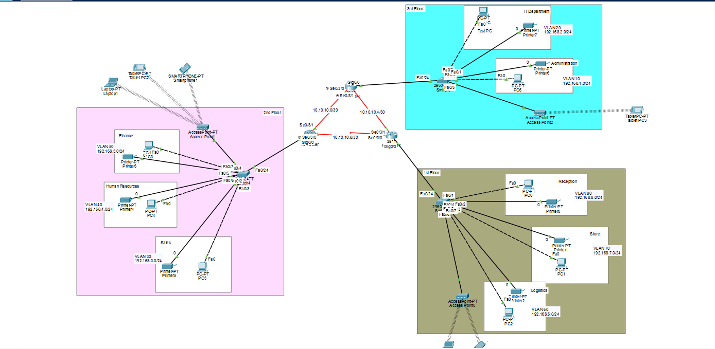

3.2 IP Addressing Scheme

3.2.1 VLAN & Subnet Assignments
The table below summarizes the VLAN IDs and subnets assigned to each department:

Floor | Department | VLAN ID | Network
1 | Reception | 80 | 192.168.8.0/24
1 | Store | 70 | 192.168.7.0/24
1 | Logistics | 60 | 192.168.6.0/24
2 | Finance | 50 | 192.168.5.0/24
2 | HR | 40 | 192.168.4.0/24
2 | Sales | 30 | 192.168.3.0/24
3 | IT Department | 20 | 192.168.2.0/24
3 | Administration | 10 | 192.168.1.0/24

3.2.2 Router Serial (WAN) Links
The three routers are interconnected via serial DCE cables using the following /30 networks:

Link | Router A | Router B | Network
Link 1 | F1-Router | F2-Router | 10.10.10.8/30
Link 2 | F2-Router | F3-Router | 10.10.10.0/30
Link 3 | F1-Router | F3-Router | 10.10.10.4/30

3.3 Device Inventory
List all devices included in the topology, their roles, and placement:

# | Device | Type | Location / Role
1 | F1, F2, F3 Routers | Router | All Floors — Inter-VLAN routing, DHCP, OSPF, SSH
2 | F1, F2, F3 Switches | Switch | All Floors — VLAN segmentation, Port Security on F3
3 | PCs & Printers | End Device | All Floors — Wired user devices in each department
4 | Test-PC | End Device | Floor 3 IT Department — SSH remote management
5 | Laptops, Smartphones, Tablets | End Device | Floor 1 , 2 & 3 Wireless user devices
6 | F1, F2, F3 Access Points | Access Point | All Floors — Wireless connectivity for mobile devices

4. Implementation

4.1 Network Topology Construction
The network topology for Vic Modern Hotel was designed and built using Cisco Packet Tracer. The construction process was carried out in the following steps:

1. Device Placement
All network devices were placed in Cisco Packet Tracer according to the three floor layout. Each floor was given a dedicated area containing one router, one switch, and the respective department end devices including PCs, printers, laptops, smartphones, and tablets. Access points were placed on Floor 1 and Floor 2 to provide wireless connectivity.

2. Device Connections and Cable Types
The following cable types were used for each connection:
Connection | Cable Type
PC / Printer to Switch | Straight-through copper cable
Switch to Router | Straight-through copper cable
Access Point to Switch | Straight-through copper cable
Router to Router (Serial links) | Serial DCE cable
Laptop / Smartphone / Tablet to Access Point | Wireless connection

3. Serial Links Between Routers
The three routers were interconnected using serial DCE cables to simulate WAN links between floors. The connections have been mentioned in the section 3.2.2

4. VLAN Logical Topology
After physical connections were made, VLANs were created on each switch to logically separate department traffic. Each switch port connected to a department device was assigned to its respective VLAN as access port. The port connecting the switch to the router was configured as a trunk port to carry all VLAN traffic between the switch and router.

5. Subinterface Configuration on Routers
Each router was configured with subinterfaces on GigabitEthernet0/0 for each VLAN using router-on-a-stick method. Each subinterface was assigned a unique IP address serving as the default gateway for its respective VLAN.

4.2 VLAN Configuration

Switch 1 Configuration:

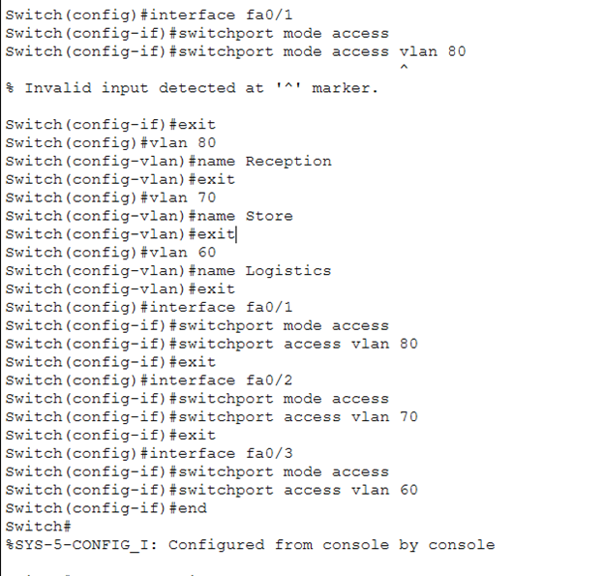

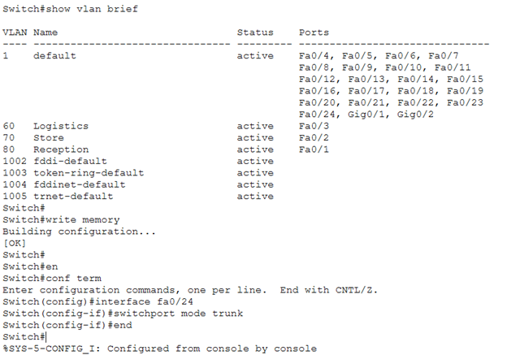

4.3 Trunk Link Configuration

Trunk links were configured between each floor switch and its corresponding router to allow traffic from multiple VLANs to pass through a single physical link using 802.1Q encapsulation. Since each router was configured with multiple subinterfaces using the router-on-a-stick method, the switch needed to send tagged frames from all VLANs to the router on one port. This was achieved by setting the connecting port to trunk mode using the command switchport mode trunk on the interface connecting each switch to its router. The 802.1Q protocol automatically tags each Ethernet frame with its VLAN ID, allowing the router to identify which subinterface should process the incoming traffic. This trunk configuration was applied on F1, F2, and F3 switches and was verified using the show interfaces trunk command which confirmed that all VLANs were allowed and actively trunking across the link.

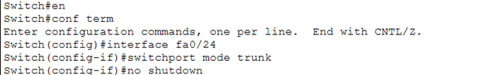

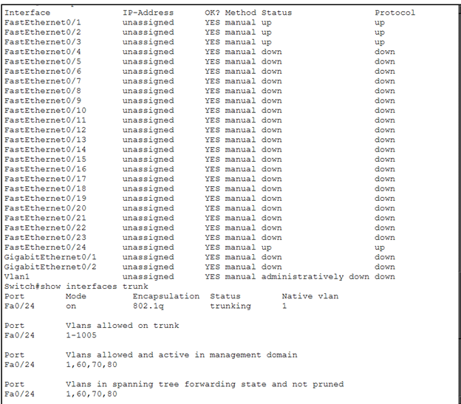

4.4 Inter-VLAN Routing (Router on a Stick)

Inter-VLAN routing was implemented using the router-on-a-stick method, where the GigabitEthernet0/0 interface on each router was divided into multiple logical subinterfaces, one for each VLAN. Each subinterface was configured with dot1Q encapsulation matching its VLAN ID and assigned a gateway IP address for that department. For example, on F1 Router, subinterface Gig0/0.80 was assigned to Reception VLAN 80 with gateway 192.168.8.1, Gig0/0.70 for Store VLAN 70 with gateway 192.168.7.1, and Gig0/0.60 for Logistics VLAN 60 with gateway 192.168.6.1. The same approach was applied on F2 and F3 routers for their respective VLANs, enabling all departments across all floors to communicate through their local router.

F1- Router Configuration:

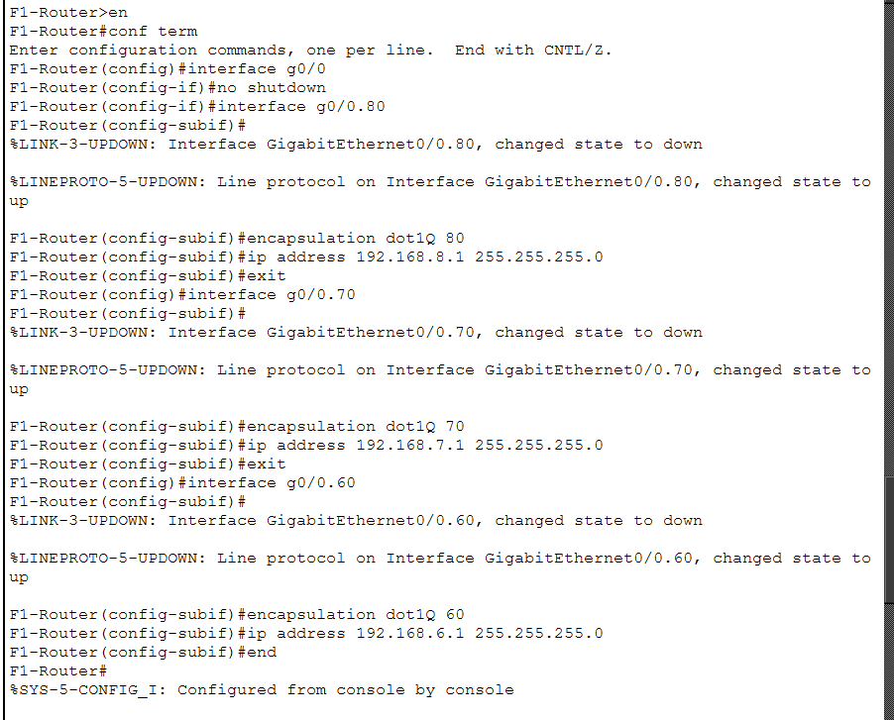

4.5 OSPF Configuration

OSPF (Open Shortest Path First) was configured on all three routers using process ID 10 and area 0 (backbone area). Each router was configured to advertise all its directly connected networks including its VLAN subnetworks and serial WAN links. This allows all three routers to dynamically share routing information with each other, enabling devices on different floors to communicate seamlessly. The wildcard masks were used to define which networks to advertise in the OSPF process..

OSPF Configuration Commands

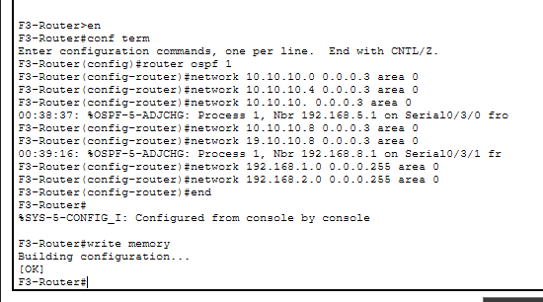

4.6 DHCP Configuration

Each router was configured as a DHCP server to automatically assign IP addresses to devices connected to its respective VLANs. DHCP pools were created for each department with the pool name matching the department name, the network address, default gateway, and DNS server. The gateway IP address of each VLAN subinterface was excluded from the DHCP pool using the ip dhcp excluded-address command to prevent it from being assigned to end devices. This ensures that every device connected to the network receives a correct IP address, subnet mask, default gateway, and DNS server automatically without any manual configuration.

DHCP Configuration Commands

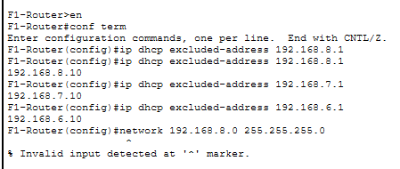

4.7 SSH Configuration

SSH (Secure Shell) was configured on all three routers to enable secure remote management of the network. SSH provides encrypted communication between the network administrator and the routers, preventing unauthorized access and data interception. The configuration involved setting a unique hostname and domain name on each router, creating a local username and password for authentication, generating RSA encryption keys of 1024 bits, and configuring the VTY lines to accept only SSH connections using local login authentication. The Test-PC located in the IT Department on Floor 3 was used to remotely access and manage all three routers via SSH.

SSH Configuration Commands

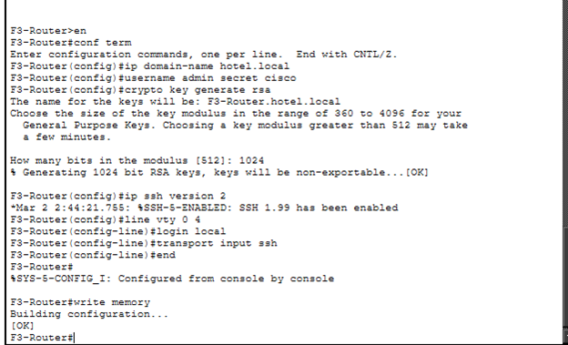

4.8 Wireless LAN (WLAN) Configuration
Cisco Access Points were added to all three floors in Cisco Packet Tracer to provide wireless connectivity for mobile devices such as laptops, smartphones, and tablets. Each access point was connected to its floor switch via a straight-through cable. The SSIDs were configured as Floor1, Floor2, and Floor3 for their respective floors. WPA2-PSK security was enabled on each access point with a password to prevent unauthorized wireless access. Wireless client devices including laptops, smartphones, and tablets were configured to connect to their respective floor access point by selecting the correct SSID and entering the WPA2-PSK password. Once connected, all wireless devices automatically received IP addresses from the DHCP server configured on their floor router, confirming successful wireless connectivity.

WLAN Details
Fill in the wireless configuration details: Floor 1 SSID: __Floor1__________ Security: WPA2 Password: __AccessPoint1__________ Floor 2 SSID: ______ Floor2______ Security: WPA2 Password: _____ AccessPoint2_______ Floor 3 SSID: ____ Floor3________ Security: WPA2 Password: _____ AccessPoint3_______

4.9 Port Security Configuration

Port security was configured on port Fa0/1 of the Floor 3 switch, which is connected to the Test-PC in the IT Department. The sticky MAC address method was used, allowing the switch to automatically learn and save the Test-PC's MAC address the first time it sends traffic. The maximum allowed MAC addresses was set to 1, and the violation mode was set to shutdown so that if any unauthorized device attempts to connect, the port automatically disables itself. This was verified using show port-security interface fa0/1 which confirmed port status as secure-up with one sticky MAC address successfully learned.

Port Security Commands

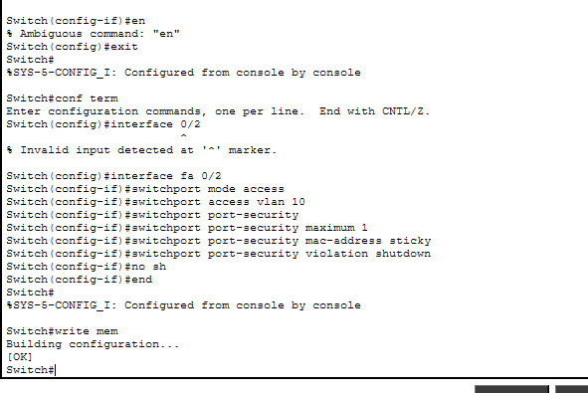

5. Testing and Verification

5.1 Intra-VLAN Connectivity Test

Test Result
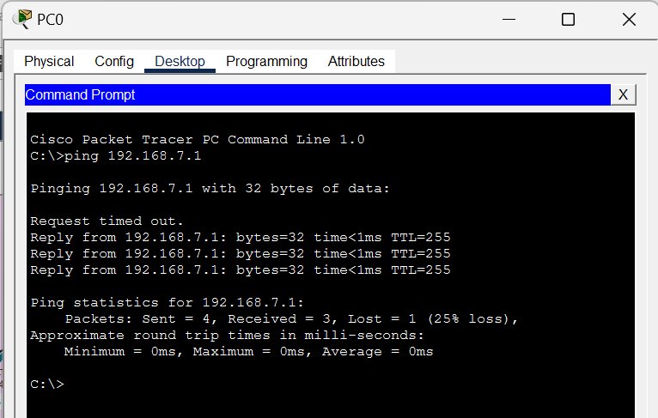

Source IP: 192.168.8.2 Destination IP: 192.168.7.1 Result: Success

5.2 Inter-VLAN Connectivity Test

Test Result

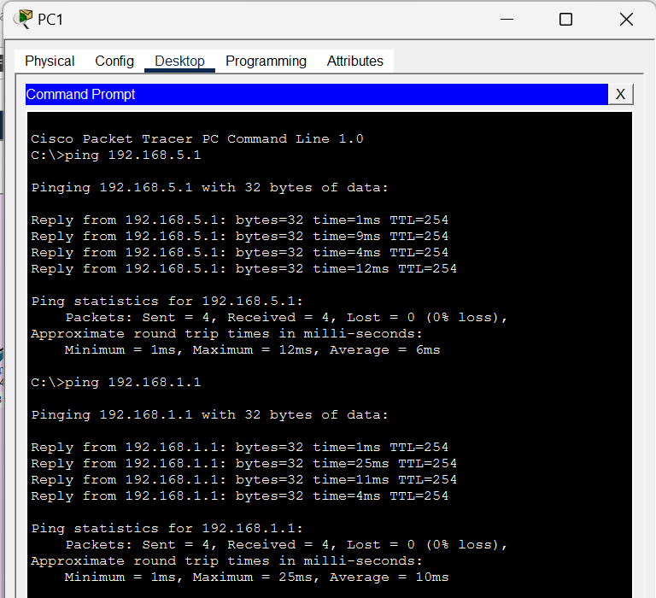

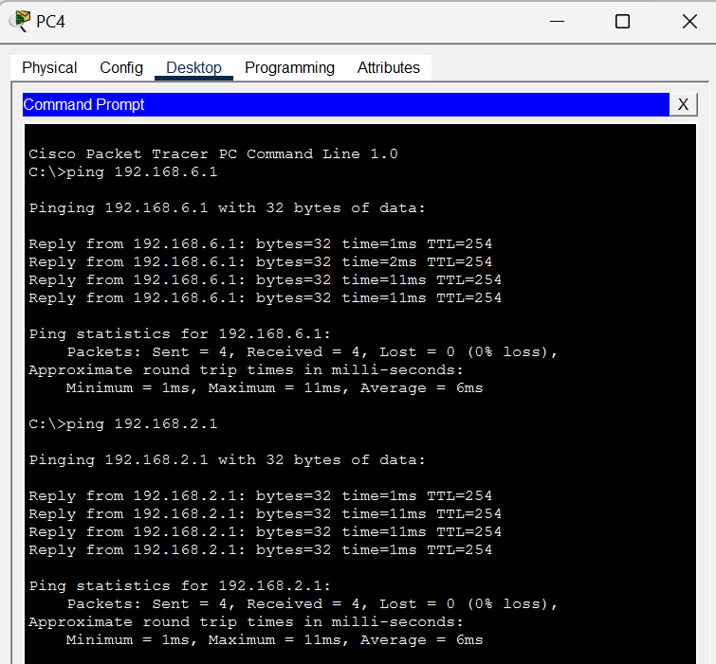

5.3 DHCP Verification

Department / VLAN | Obtained IP Address
Reception / VLAN 80 | 192.168.8.2
Store / VLAN 70 | 192.168.7.2
Logistics / VLAN 60 | 192.168.6.2
Finance / VLAN 50 | 192.168.5.2
Human Resources / VLAN 40 | 192.168.4.2
Sales / VLAN 30 | 192.168.3.2
IT Department / VLAN 20 | 192.168.2.2
Administration / VLAN 10 | 192.168.1.2

5.4 OSPF Route Verification

Test Result

F1-Router
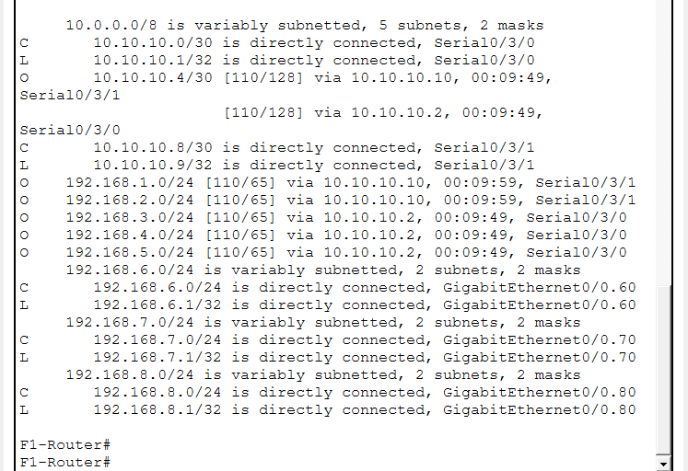

F2-Router

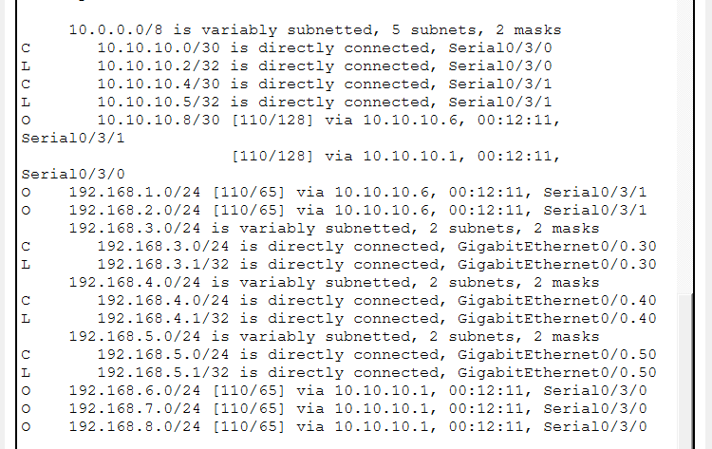

F3-Router

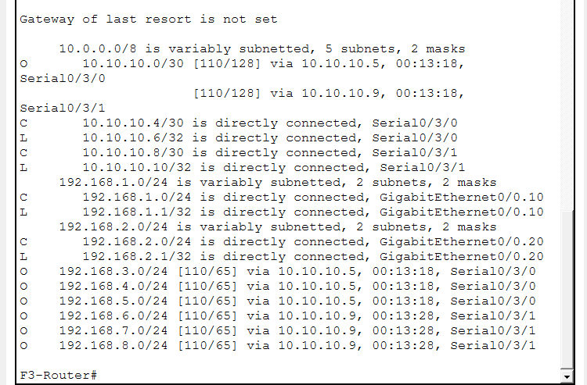

5.5 SSH Remote Login Test

Test Result

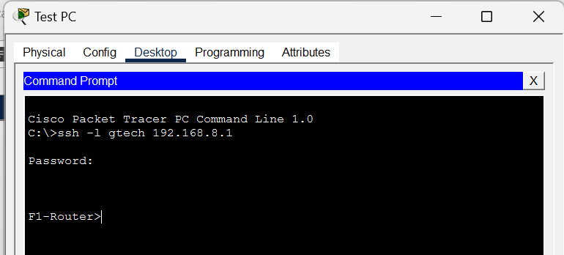
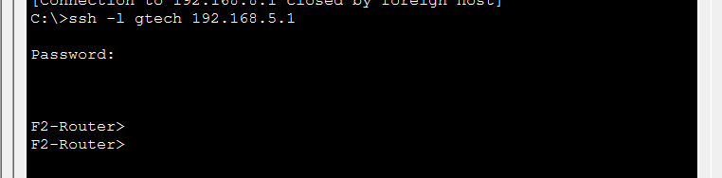

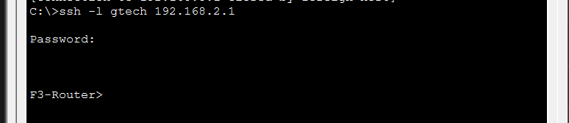

5.6 Port Security Test
Verify that Test-PC is the only device allowed on Fa0/1. Connect a different device and confirm the port shuts down.
Test Result

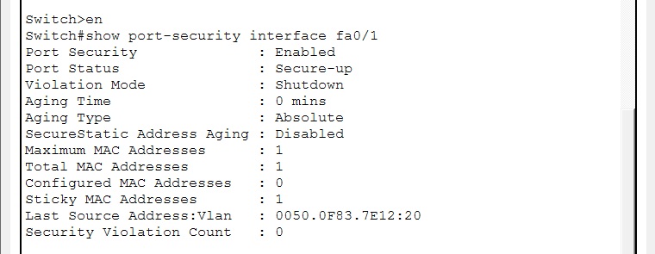

Violation

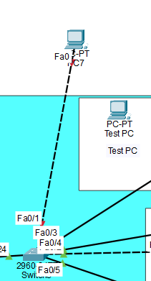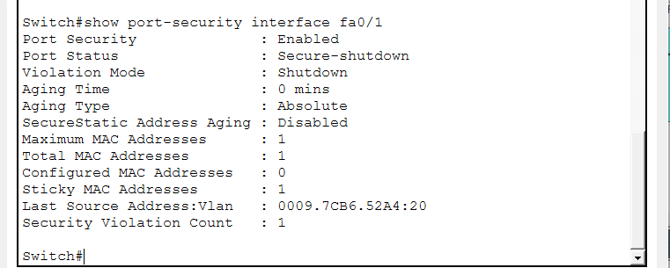

5.7 Wireless Connectivity Test
Connect a laptop or smartphone to each floor's WLAN and verify it obtains a DHCP address and can ping devices in the same and different VLANs.
Test Result

Floor 1

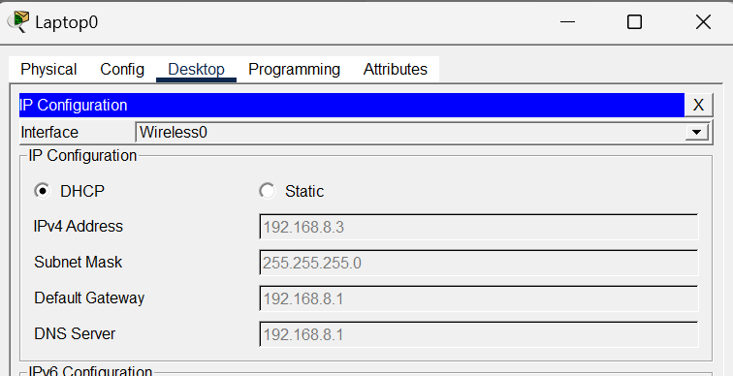

Floor 2
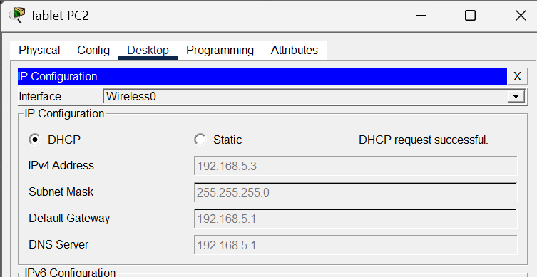

Floor 3

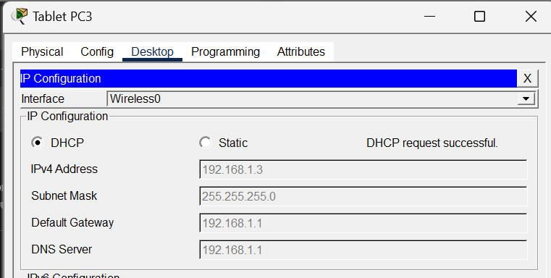

6. Discussion

6.1 Analysis of Results
The network performed as expected across all configured technologies. DHCP successfully assigned IP addresses to all wired and wireless devices on every floor with correct gateway and DNS settings. OSPF converged properly between all three routers, with full routing tables showing all eight department networks reachable from any floor. SSH remote login was successfully established from Test-PC to all three routers confirming secure encrypted management access. Port security correctly blocked unauthorized devices on the IT department switch port. Wireless connectivity was verified on all floors with mobile devices obtaining DHCP addresses and successfully pinging devices across different VLANs.

6.2 Design Decisions
Router-on-a-stick was chosen over a Layer 3 switch because it is more cost effective for a small hotel network where a single router can handle inter-VLAN routing for multiple departments without requiring expensive multilayer switching hardware. OSPF was selected over static routing because it automatically adapts to network changes and scales better as the hotel network grows, and over EIGRP because OSPF is an open standard supported by all vendors. VLANs were numbered in tens starting from 10 to allow room for future department additions without reorganizing the existing numbering scheme. Each floor was assigned a dedicated router and switch following a hierarchical design approach, ensuring that network traffic is localized per floor and reducing unnecessary load on other floors. Serial DCE/DTE links were used to interconnect the three routers simulating real world WAN connections between floors, with /30 subnets chosen for serial links to minimize IP address wastage as only two addresses are needed per point-to-point link. DHCP was configured locally on each floor router rather than using a centralized DHCP server, ensuring that devices on each floor can still obtain IP addresses even if connectivity to other floors is lost. Sticky MAC addressing was selected for port security over static MAC configuration because it automatically learns the authorized device MAC address without requiring manual entry, making it easier to manage in a real deployment.

6.3 Security Considerations
The network implemented SSH for secure encrypted remote management and port security to restrict unauthorized device access on the IT department switch. However for a real hotel deployment additional security measures should be considered including Access Control Lists to filter traffic between departments, WPA2-Enterprise with a RADIUS server for stronger wireless authentication, VPN tunnels for secure remote access over the internet, and TACACS+ for centralized network device authentication and authorization logging.

6.4 Scalability and Future Improvements
The current network can be easily expanded by adding additional floors with new routers and switches following the same design pattern, with OSPF automatically advertising new networks to existing routers. Future improvements could include implementing HSRP or VRRP for router redundancy to eliminate single points of failure, deploying a centralized RADIUS server for unified wireless and device authentication, adding QoS policies to prioritize VoIP and video conferencing traffic, and introducing a network management system such as Cisco DNA Center for centralized monitoring and management of all network devices.

7. Conclusion

This project successfully demonstrated the design and implementation of a fully functional, secure, and scalable enterprise network for Vic Modern Hotel using Cisco Packet Tracer. The network was built across three floors with eight departments, each isolated using dedicated VLANs to ensure traffic segmentation and improved network performance.
All objectives defined in Section 2.3 were successfully achieved. A hierarchical three floor network topology was designed and implemented with dedicated routers and switches on each floor. VLAN segmentation was configured for all eight departments, and inter-VLAN routing was successfully enabled using the router-on-a-stick method allowing seamless communication between all departments. OSPF was deployed across all three routers enabling dynamic route advertisement and full inter-floor connectivity. DHCP was configured on each router to automatically assign correct IP addresses, subnet masks, gateways, and DNS settings to all connected devices. SSH was enabled on all three routers allowing the IT department to securely manage the entire network remotely from the Test-PC. Wireless connectivity was successfully implemented on all floors through Cisco Access Points, providing Wi-Fi access for mobile devices. Port security was enforced on the IT department switch to prevent unauthorized device access using the sticky MAC address method.
Through this project several important networking concepts were learned and applied in a practical environment, including VLAN design, dynamic routing protocols, DHCP server configuration, secure remote access, and wireless network setup. The technologies configured in this project are widely used in real world enterprise environments, particularly in the hospitality industry where secure, reliable, and segmented network infrastructure is essential for supporting both staff operations and guest services. This simulation provided valuable hands-on experience that directly reflects the challenges and solutions encountered in professional network design and deployment.

